The Lyric League
Youth Arts Celebration 2022
Sponsorship Opportunities

Show  Producer | $5,000  (2 max) | Includes:  Private Box Seats with wine for up to six (6) guests  Inclusion in Lyric website, social media, e-blasts, and marketing materials as YAC Sponsor*  Signage in The Lyric Theatre at YAC and listing in YAC program as Sponsor*  Photo opportunity for you/your organization with YAC performers  You or a member of your organization may be a judge for YAC auditions on March 1 & 5 2022.
Stage  Director | $2,500 | Includes:  Six (6) preferred tickets  Inclusion in Lyric website, social media, e-blasts, and marketing materials as YAC Sponsor*  Signage in The Lyric Theatre at YAC and listing in YAC program as Sponsor*  Photo opportunity for you/your organization with YAC performers
Tour  Manager | $1,000 | Includes:  Four (4) tickets  Inclusion in Lyric website, social media, e-blasts, and marketing materials as YAC Sponsor*  Signage in The Lyric Theatre at YAC and listing in YAC program as Sponsor*  Listing in YAC program as Sponsor*
Headliner | $500 | Includes:  Two (2) tickets  Inclusion in Lyric website, social media, e-blasts, and marketing materials as YAC Sponsor*  Listing in YAC program as Sponsor*
Talent  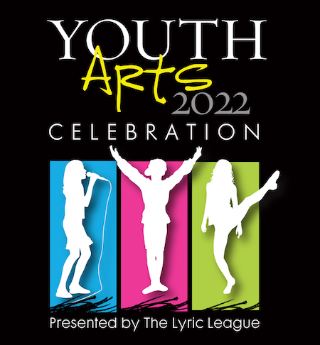  Scout | $150 | Includes:  Two (2) tickets  Listing in YAC program as Sponsor*
*Sponsor to provide logo, sponsorship listing and signage where applicable.

For more information regarding sponsorships contact:
Sue Nauss: (772) 286-7827 / Sue@lyrictheatre.com

The Lyric Theatre / Friends of the Lyric, Inc. is a 501(c)3 organization registered in the State of Florida. No goods or services were provided in connection with your contribution.

A COPY OF THE OFFICIAL REGISTRATION (CH1579) AND FINANCIAL INFORMATION MAY BE OBTAINED FROM THE DIVISION OF CONSUMER SERVICES BY CALLING 1-800-HELP-FLA (435-7352) OR VISITING WWW.FLORIDACONSUMERHELP.COM WITHIN THE STATE. REGISTRATION DOES NOT IMPLY ENDORSEMENT, APPROVAL, OR RECOMMENDATION OF THE STATE

The Lyric League
Youth Arts Celebration 2022
Sponsorship Commitment Form

I would like to commit to be a sponsor for The Lyric League Youth Arts Celebration at the following level:

$150 Talent Scout
$500 Headliner
$5,000 Show Producer
$1,000 Tour Manager
$2,500 Stage Director
I do not wish to be a sponsor, but I would like to make a donation in the amount of: ___________
Please make check payable to The Lyric Theatre with a reference to YAC
Name: _______________________________________________ organization:____________________________________
Email: _______________________________________________________ Phone: ___________________________________
Address: _______________________________________________________________________________________________
City, State, Zip: __________________________________________________________________________________________
Sponsorships received by March 15, 2022 will be included in upcoming event website, social media, e-blasts and marketing materials.
I hereby commit to be a sponsor for The Lyric League Youth Arts Celebration and authorize Friends of The Lyric, Inc. to initiate payment applied to my credit card as indicated above.

CC: _____________________________________________________________________________________

CVV: _______________ Exp Date: ________________________

Billing Address: ______________________________________________________________________

__________________________________________________ / _____________________________
Authorized Signature Date

Please make checks payable to: The Lyric Theatre

- RETURN completed form AND PAYMENT:
  - VIA MAIL: The Lyric Theatre, 59 SW Flagler Avenue, Stuart, FL 34994, Attn: Youth Arts CElebration
  - via scan & email: sue@lyrictheatre.com Subject Line: YAC Sponsorship

For more information regarding sponsorships contact:
Sue Nauss: (772-286-7827) / Sue@lyrictheatre.com

Thank you for your support of The Lyric Theatre Arts & Education Programs!
The Lyric Theatre / Friends of the Lyric, Inc. is a 501(c)3 organization registered in the State of Florida. No goods or services were provided in connection with your contribution.

A COPY OF THE OFFICIAL REGISTRATION (CH1579) AND FINANCIAL INFORMATION MAY BE OBTAINED FROM THE DIVISION OF CONSUMER SERVICES BY CALLING 1-800-HELP-FLA (435-7352) OR VISITING WWW.FLORIDACONSUMERHELP.COM WITHIN THE STATE. REGISTRATION DOES NOT IMPLY ENDORSEMENT, APPROVAL, OR RECOMMENDATION OF THE STATE

